Alfred Packer

**The Colorado Cannibal**

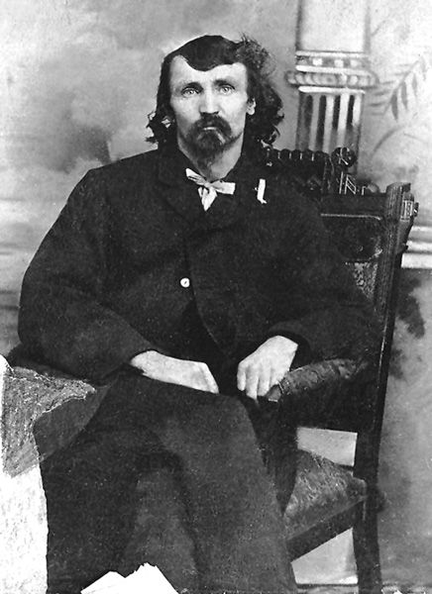

**An expedition gone wrong:**

On June 8, 1886, Alfred Packer was convicted of murder and sentenced to 40 years in prison. What took place in the San Juan Mountains in Colorado? What did the bones show of the remains of the five allegedly killed by Packer? Do you think he was guilty or not guilty of the crime?

**Directions:**

Research who Alfred Packer was. What happened in the San Juan Mountains in Colorado? What did the remains killed by Packer show? Do you think that he was guilty or not guilty of the crime? Responses should be one and a half pages long and make sure to use the proper essay format in your responses.